CLINICAL RECORD LINKAGE & CARE COORDINATION PLATFORM

Project Report submitted for the partial fulfilment of grade for the course

Data Structures and Algorithms -3 (25CS2103E)
in

A.Y. 2026-2027

Submitted by
R.VIPUL (25200080056)
U.VINAY SAMPATH (2520090140)

Team Number: 20
Section: 11

Under the guidance of

Mrs. Ch. Anitha

Asst. Professor, CS&IT
Hyderabad-500090, Telangana, India.

K L (Deemed to be) University
DEPARTMENT OF COMPUTER SCIENCE AND INFORMATION TECHNOLOGY
CS&IT and AI&DS



DECLARATION

The Mini Project Report entitled “CLINICAL RECORD LINKAGE & CARE COORDINATION PLATFORM” is a record of Bonafide work of R.VIPUL – 25200080056, U.VINAY SAMPATH – 2520090140 submitted in partial fulfillment for the award of B. Tech in CSIT AND AI&DS to the K L University. The results embodied in this report have not been copied from any other departments/University/Institute.

R.VIPUL – 25200080056
U.VINAY SAMPATH – 2520090140

K L (Deemed to be) University
DEPARTMENT OF COMPUTER SCIENCE AND INFORMATION TECHNOLOGY
CERTIFICATE

This is to certify that the mini project based report entitled “CLINICAL RECORD LINKAGE & CARE COORDINATION PLATFORM” is a bonafide work done and submitted by R.VIPUL – 25200080056, U.VINAY SAMPATH – 2520090140 in partial fulfillment of the requirements for the award of the degree of BACHELOR OF TECHNOLOGY in Department of CSIT AND AI&DS, K L (Deemed to be University), during the academic year 2026-2027.

Signature of the Supervisor

Signature of the HOD Signature of the External Examiner

ACKNOWLEDGEMENT

The success in this project would not have been possible but for the timely help and guidance rendered by many people. Our wish to express my sincere thanks to all those who has assisted us in one way or the other for the completion of my project.

Our greatest appreciation to my guide, Mrs. Ch. Anitha, Asst. Professor, Department of Computer Science and Information Technology, which cannot be expressed in words for her tremendous support, encouragement and guidance for this project.

We express our gratitude to Dr. Khaja Shareef,Hod of CS&IT ,Sreenath Itikela , Head of the Dep AI&DS for providing us with adequate facilities, ways and means by which we are able to complete this project-based Lab.

We thank all the members of teaching and non-teaching staff members, and also who have assisted me directly or indirectly for successful completion of this project. Finally, I sincerely thank my parents, friends and classmates for their kind help and cooperation during my work.

R.VIPUL – 25200080056
U.VINAY SAMPATH –2520090140

TABLE OF CONTENTS

S.No. | Contents | Page no.
1. | Abstract | 6
2. | Introduction | 7
3. | Literature survey | 8
4. | Problem Statement and Objectives | 10
5. | Hardware and Software requirements | 11
6. | Implementation | 12
7. | Results & Discussion | 14
8. | Conclusion & Future Scope | 15
9. | References | 16

1.ABSTRACT

The Clinical Record Linkage and Care Coordination Platform is a secure digital healthcare system that connects patient records from different hospitals, clinics, laboratories, and pharmacies into a single, unified platform. It enables authorized healthcare professionals to access accurate and up-to-date medical information, including patient history, diagnoses, prescriptions, laboratory reports, allergies, and treatment plans. The platform improves communication and collaboration among doctors, specialists, nurses, and other healthcare providers, ensuring coordinated and continuous patient care. By reducing duplicate medical tests, preventing medication errors, and enabling faster clinical decisions, it enhances healthcare efficiency and patient safety. The system incorporates strong security features such as encryption, role-based access control, and patient consent management to protect sensitive health information and maintain data privacy. It also supports interoperability between different healthcare systems, making information exchange seamless and reliable. Overall, the platform improves the quality of healthcare services, reduces operational costs, enhances patient outcomes, and provides a scalable, efficient, and patient-centered solution for modern healthcare management.
Team Name: Team 20

Team Logo (if any): Not applicable

Team Members:
- R.VIPUL, 25200080056
- U.VINAY SAMPATH, 2520090140

- INTRODUCTION

Healthcare data is rarely stored in one place. A single patient may visit a clinic for a check-up, a laboratory for blood tests, a hospital for treatment and a pharmacy for medicines, and each of these institutions keeps its own record under its own patient identifier. As a result, doctors often see only a fragment of the patient's history, which leads to repeated tests, missed allergies, conflicting prescriptions and delays in treatment.
The Clinical Record Linkage and Care Coordination Platform addresses this problem by (i) identifying records that belong to the same person across different sources and linking them into one master patient record, (ii) allowing only authorized users, and only with the patient's consent, to view the relevant parts of that record, and (iii) helping providers coordinate care through referral routing, urgency-based referral queues and medication-safety alerts.
The project is built around core data structures and algorithms covered in the course: hash tables for blocking and fast lookup, the Union-Find (disjoint set) structure for merging duplicate records, graphs with breadth-first search for referral paths between providers, a priority queue (heap) for urgency-based referrals, and hash sets for allergy and interaction checks. These choices keep each operation close to constant or logarithmic time even as the number of records grows.
The rest of this report is organised as follows: Section 3 surveys existing work, Section 4 states the problem and objectives, Section 5 lists hardware and software requirements, Section 6 presents the implementation modules, Section 7 discusses the results, Section 8 gives the conclusion and future scope, and Section 9 lists the references.
- LITERATURE SURVEY
Fellegi–Sunter probabilistic record linkage (1969). The classical statistical theory of record linkage. It compares fields such as name, date of birth and address between two records, assigns match and non-match weights, and classifies the pair as a match, possible match or non-match. Most modern linkage tools, including Splink, are based on this model. Its limitation is that comparing every pair of records is expensive, which is why blocking is used.
Splink (UK Ministry of Justice). An open-source Python library for probabilistic record linkage and deduplication at scale, based on the Fellegi–Sunter model. It uses blocking rules to limit the number of comparisons and clusters matched records into entities. It is widely used for linking administrative and health datasets, but it provides only the linkage step and has no consent management or care-coordination features.
dedupe (Python library). An open-source library that learns from a few labelled examples which fields matter for deciding whether two records are duplicates. It uses blocking and hierarchical clustering to group duplicate records. It works well for cleaning a single dataset, but it is not designed for live, multi-institution healthcare exchange or for access control.
HL7 FHIR. A standard from HL7 International that defines healthcare data as resources (Patient, Observation, MedicationRequest and others) exchanged through web APIs. It solves the problem of a common data format between systems, but it does not by itself decide whether two Patient resources from different hospitals describe the same person, so a linkage layer is still required.
CommonWell Health Alliance. A US health-information network that gives participating providers access to a patient's records across vendors. It includes a patient-identity linking service to match patients across member systems. It shows that cross-organisation record linking is practical, but it is a large proprietary network and not a small, open design that can be studied algorithmically.
Carequality. A national interoperability framework in the United States that sets common rules so that different health-information networks and EHR vendors can query each other for patient documents. It focuses on the legal and technical exchange agreement rather than on the matching and referral algorithms inside each system.
Ayushman Bharat Digital Mission (ABDM), India. India's national digital health ecosystem. It issues an ABHA health ID to each citizen, links health records held by different providers to that ID, and uses a consent manager so that records are shared only after the patient approves. It is closest to our goals; our project demonstrates the underlying linkage, consent and coordination logic at a small scale.
NIST Role-Based Access Control (RBAC). A model in which permissions are attached to roles (doctor, nurse, pharmacist) and users are assigned roles, rather than permissions being given to each user. It is the standard approach for restricting which parts of a medical record each staff member can see and is the basis of our access-control module.
HIPAA Privacy and Security Rules (USA). Regulations that define how protected health information must be kept confidential, who may access it, and how access must be logged and secured. They motivate our design choices of minimum-necessary access, patient consent and audit trails.
- Problem Statement and Objectives
Problem Statement:
Patient records are scattered across hospitals, clinics, laboratories and pharmacies, so clinicians cannot get a complete, secure and up-to-date view of a patient when they need it.

Problem Description:
Each institution stores the same patient under a different ID and in different formats, causing duplicate tests, undetected allergy or drug conflicts, and poor coordination between providers, while sharing data without controls puts patient privacy at risk.
Objectives:
1. To link records of the same patient from multiple sources into a single master patient record using hash-based blocking and the Union-Find structure.
2. To protect patient data using role-based access control, patient consent management and an audit trail of every access attempt.
3. To coordinate care by finding the shortest referral path between providers (BFS) and serving referrals in order of clinical urgency (priority queue).
4. To improve patient safety by raising automatic alerts for allergies, drug interactions and duplicate laboratory tests.
5. To design the system so that it is scalable and interoperable with other healthcare systems.
- HARDWARE AND SOFTWARE REQUIREMENTS
Hardware Requirements:
• Processor: Intel Core i3 / AMD Ryzen 3 or higher
• RAM: 4 GB minimum (8 GB recommended)
• Storage: 500 MB free disk space for the application and sample data
• Display: 1366 × 768 resolution or higher
• Input devices: keyboard and mouse
Software Requirements:
• Operating System: Windows 10/11, Linux or macOS
• Programming Language: Python 3.8 or higher (standard library only: collections, heapq)
• Code Editor / IDE: Visual Studio Code or IDLE
• Tools: Command prompt / terminal to run the program; Git for version control (optional)
- IMPLEMENTATION
The project is implemented in Python as four modules. The code of each module is given below.
Module 1: Record Linkage (m1.py)

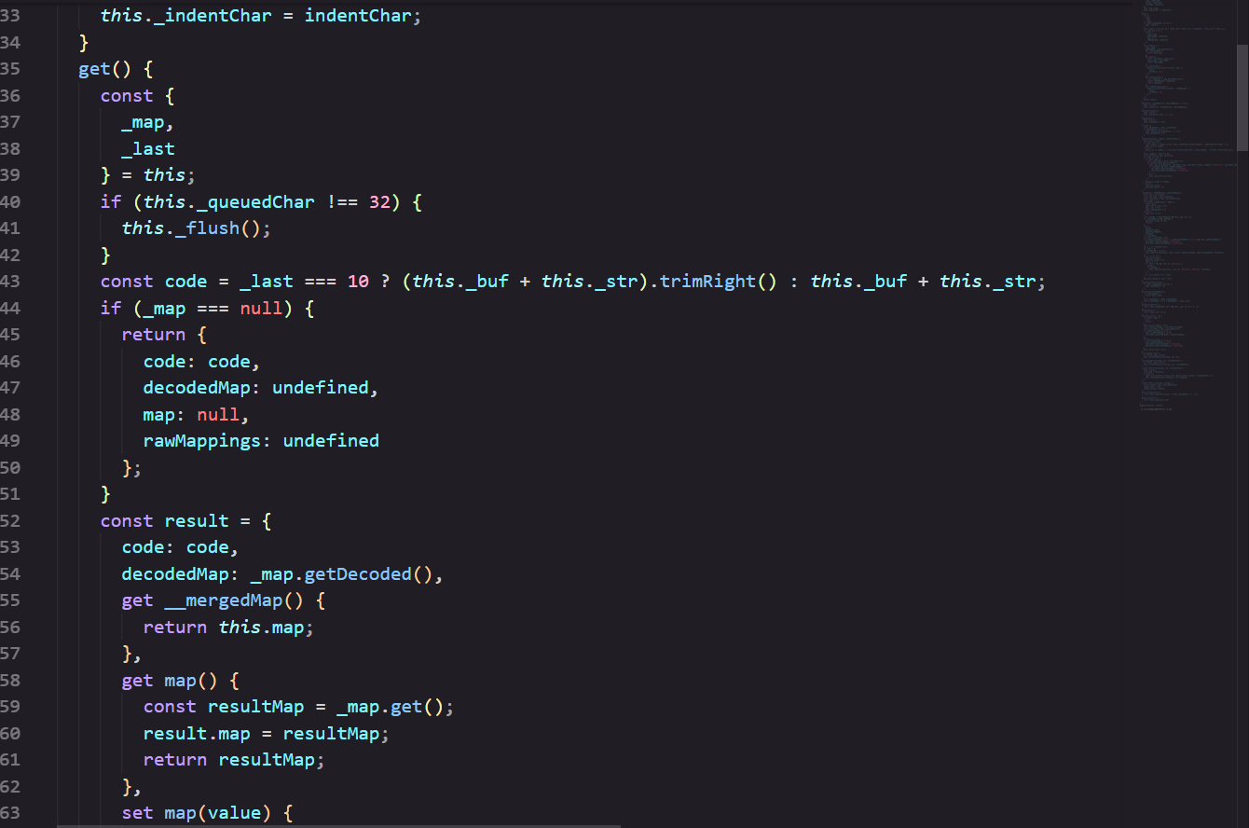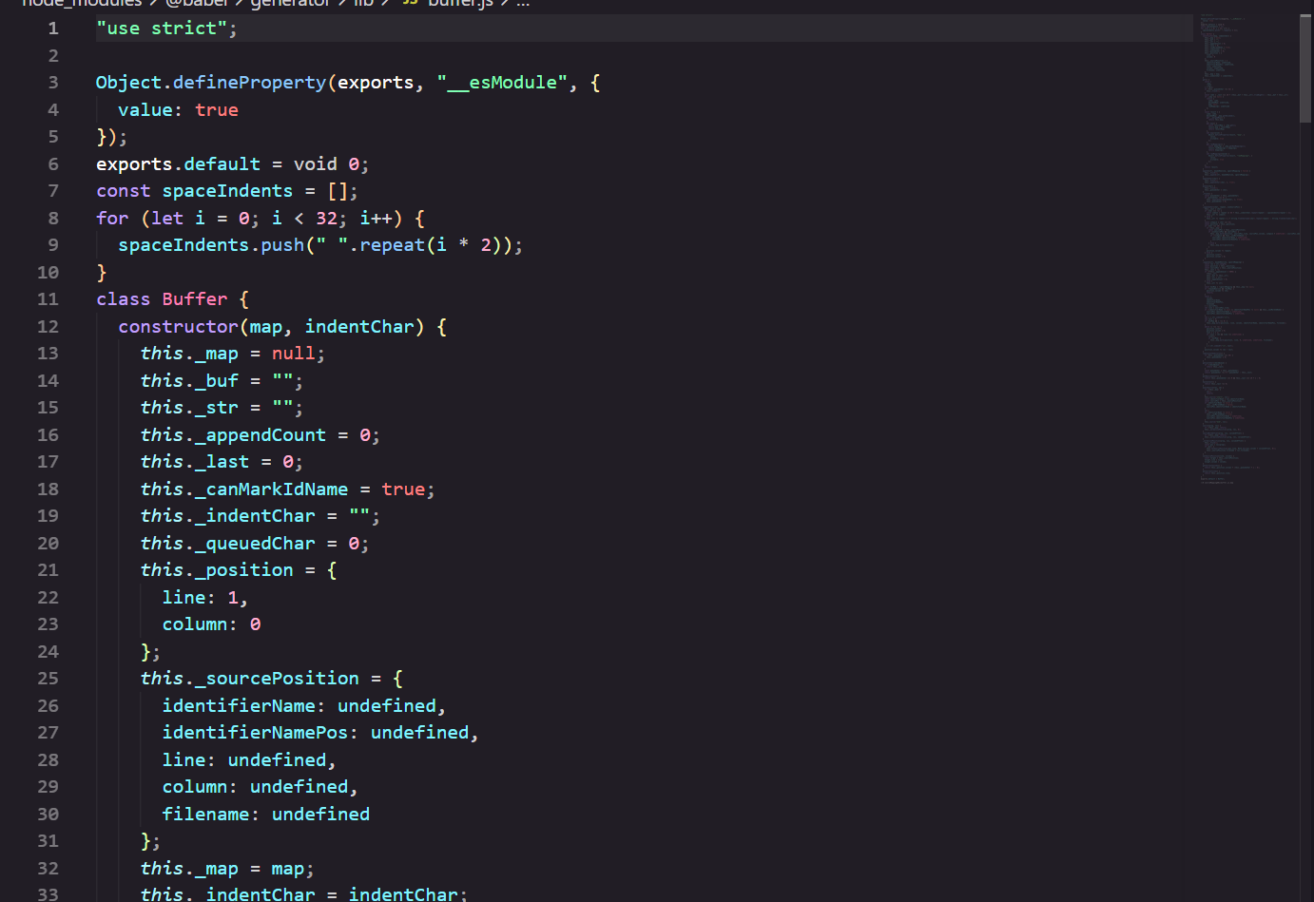
- RESULTS & DISCUSSION
The program was run from the terminal on a small sample of patient records. The console output of each module is shown below with a short explanation.

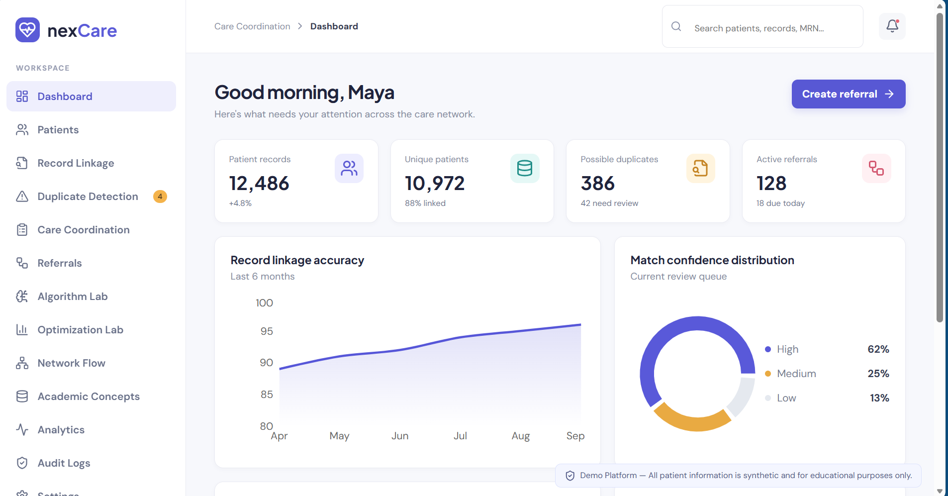
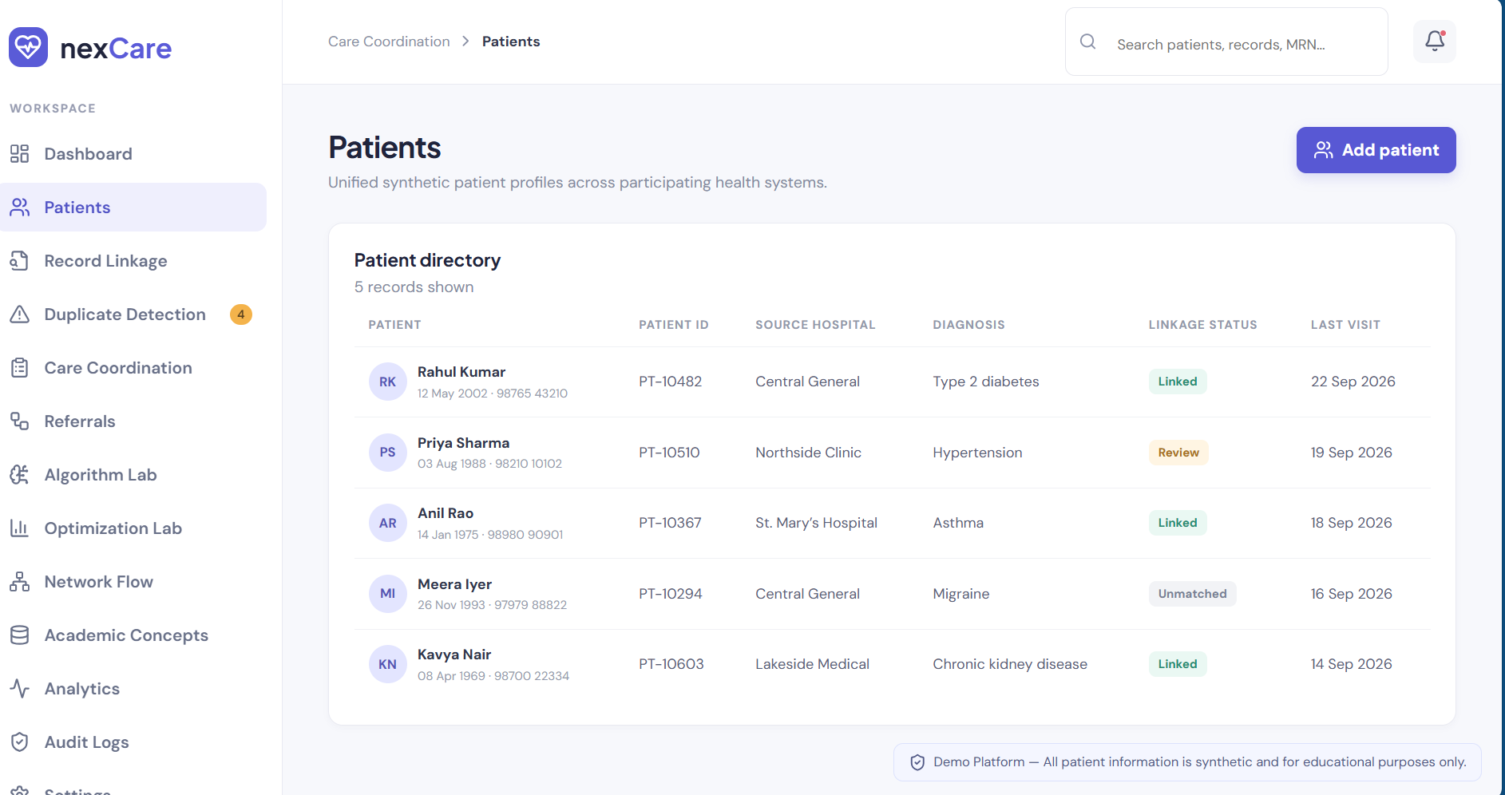
The system flagged an amoxicillin prescription for a penicillin-allergic patient and an ibuprofen–aspirin interaction, allowed a safe drug, and detected that a CBC test was already done within 30 days.
- CONCLUSION & FUTURE SCOPE
The project set out to link patient records from different sources, protect them with consent and role-based access, and support coordinated, safer care. The implemented modules meet these objectives: duplicate records of the same patient were merged into one master record, unauthorized or non-consented access was denied and logged, referrals were routed and prioritised correctly, and medication and test-duplication alerts were raised. Using hash tables, Union-Find, BFS and heaps keeps these operations efficient as data grows.
Near term: add a database back-end and a web interface, use fuzzy matching (edit distance, phonetic codes) for names, and encrypt stored records.
Medium term: support standard formats and APIs such as HL7 FHIR, probabilistic (Fellegi–Sunter) scoring to handle uncertain matches, and integration with national health IDs such as ABHA.
Long term: deploy at scale across hospital networks with real-time alerts, machine-learning based matching and clinical decision support, and mobile access for patients to manage their own consent.
- REFERENCES
1. I. P. Fellegi and A. B. Sunter, “A Theory for Record Linkage,” Journal of the American Statistical Association, vol. 64, no. 328, 1969. https://doi.org/10.1080/01621459.1969.10501049
2. HL7 International, FHIR (Fast Healthcare Interoperability Resources). https://hl7.org/fhir/
3. Splink – probabilistic record linkage library. https://github.com/moj-analytical-services/splink
4. dedupe – Python library for fuzzy matching and deduplication. https://github.com/dedupeio/dedupe
5. CommonWell Health Alliance. https://www.commonwellalliance.org
6. Carequality – interoperability framework. https://carequality.org
7. Ayushman Bharat Digital Mission (ABDM), Government of India. https://abdm.gov.in
8. NIST, Role Based Access Control. https://csrc.nist.gov/projects/role-based-access-control
9. U.S. Department of Health & Human Services, HIPAA. https://www.hhs.gov/hipaa/index.html
10. T. H. Cormen, C. E. Leiserson, R. L. Rivest and C. Stein, Introduction to Algorithms, 4th ed., MIT Press. https://mitpress.mit.edu/9780262046305/introduction-to-algorithms/

